**Wilson, Alex**

**CS214 – Database Technologies**

**HOP NUMBER 07B**

**Part 1**

**SCREENSHOT #1**

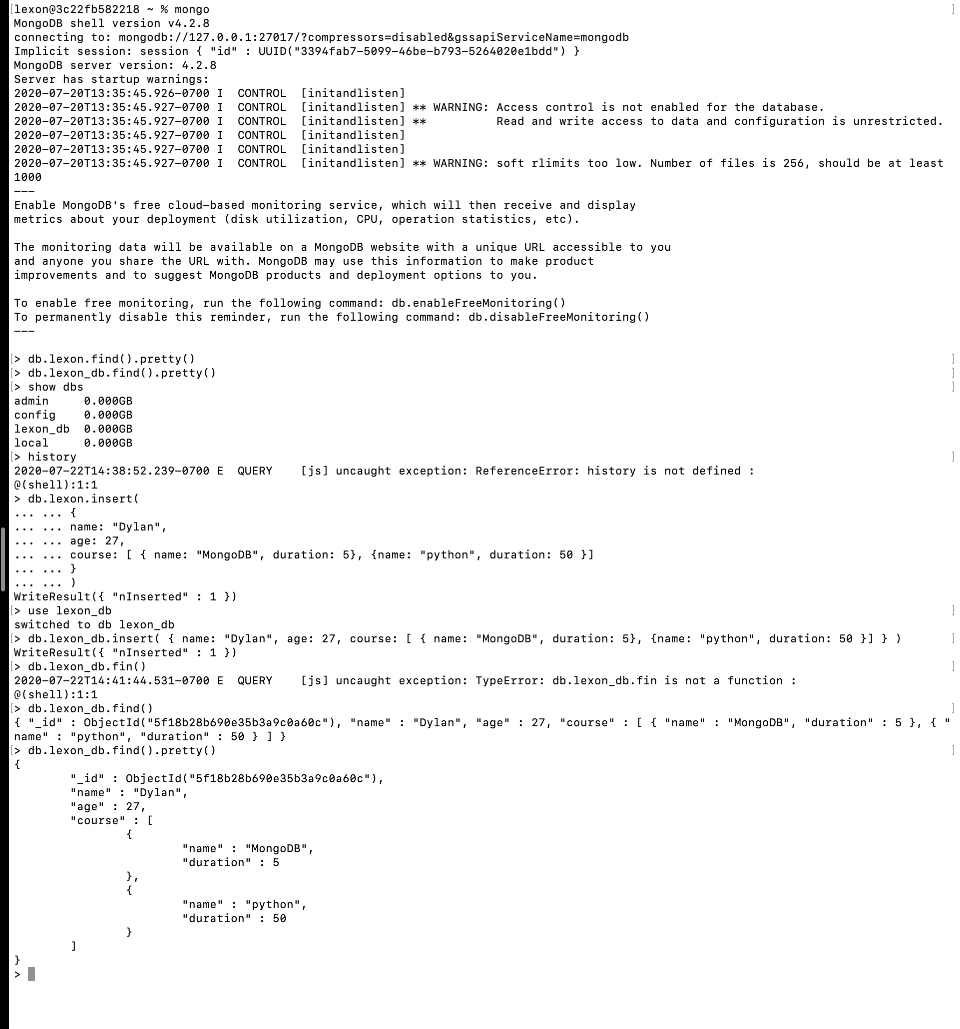

**SCREENSHOT #2**

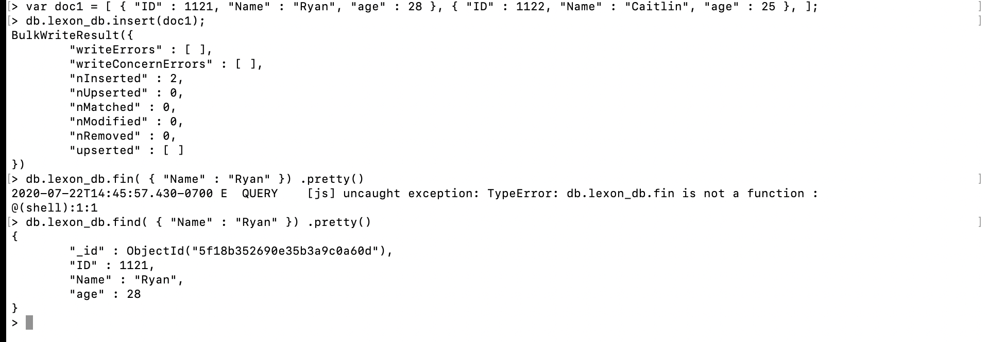

**SCREENSHOT #3**

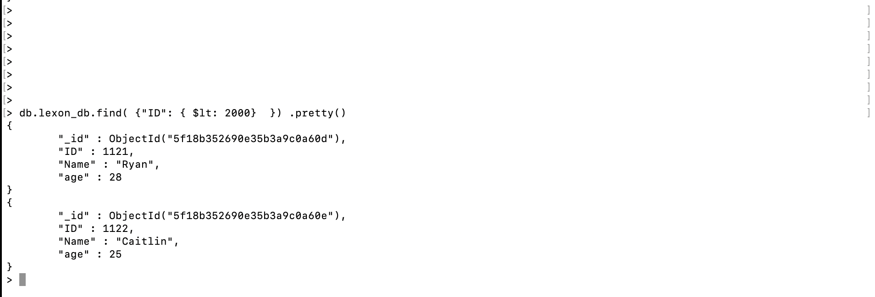

**PART 2**

This Hands-on Practice talked about Querying a Document data-type based on Criteria.

This first thing discussed is an alternate to display the output of your query in JSON format:

db.lexon_db.find().pretty()

The Equality Criteria ($eq) will bring back a document that has some matching value to the criteria cited as below:

db.lexon_db.find( { "Name" : "Ryan" }) .pretty()

{

"_id" : ObjectId("5f18b352690e35b3a9c0a60d"),

"ID" : 1121,

"Name" : "Ryan",

"age" : 28

}

The Less Than Criteria ($lt) will bring back documents where the matching values are less than the value indicated, as below:

> db.lexon_db.find( { "ID" : {$lt: 2000} }) .pretty()

{

"_id" : ObjectId("5f18b352690e35b3a9c0a60d"),

"ID" : 1121,

"Name" : "Ryan",

"age" : 28

}

{

"_id" : ObjectId("5f18b352690e35b3a9c0a60e"),

"ID" : 1122,

"Name" : "Caitlin",

"age" : 25

}

The Not Equals Criteria does the opposite of the Equality criteria; that is to say, it will bring back documents that do NOT match the criteria specified, as below:

db.lexon_db.find( { "ID":{$ne: 1122}}) .pretty()

{

"_id" : ObjectId("5f18b28b690e35b3a9c0a60c"),

"name" : "Dylan",

"age" : 27,

"course" : [

{

"name" : "MongoDB",

"duration" : 5

},

{

"name" : "python",

"duration" : 50

}

]

}

{

"_id" : ObjectId("5f18b352690e35b3a9c0a60d"),

"ID" : 1121,

"Name" : "Ryan",

"age" : 28

}